**16-BIT ADDITION**

**EXP NO: 5**

**AIM:** To write an assembly language program to implement 16-bit addition using 8085 processor.

**ALGORITHM:**

1) Start the program by loading a register pair with address of 1st number.

2)     Copy the data to another register pair.

3)      Load the second number to the first register pair.

4)      Add the two register pair contents.

5)      Check for carry.

6)      Store the value of sum and carry in memory locations.

7)      Terminate the program.

**PROGRAM:**

LDA 3050

MOV B,A

LDA 3051

ADD B

STA 3052

LDA 3053

MOV B,A

LDA 3054

ADC B

STA 3055

HLT

**INPUT:**

; Program: 16-bit addition in 8085

; Example: (2000H) = low byte of first number

; (2001H) = high byte of first number

; (2002H) = low byte of second number

; (2003H) = high byte of second number

; Result stored at 2004H (low), 2005H (high)

LDA 2000H ; Load low byte of first number into A

MOV L, A ; Move to L register

LDA 2001H ; Load high byte of first number into A

MOV H, A ; Move to H register → HL = first number

LDA 2002H ; Load low byte of second number

MOV E, A ; Move to E

LDA 2003H ; Load high byte of second number

MOV D, A ; Move to D → DE = second number

DAD D ; HL = HL + DE (16-bit addition)

SHLD 2004H ; Store result (low at 2004H, high at 2005H)

HLT ; Stop e

**OUTPUT:**

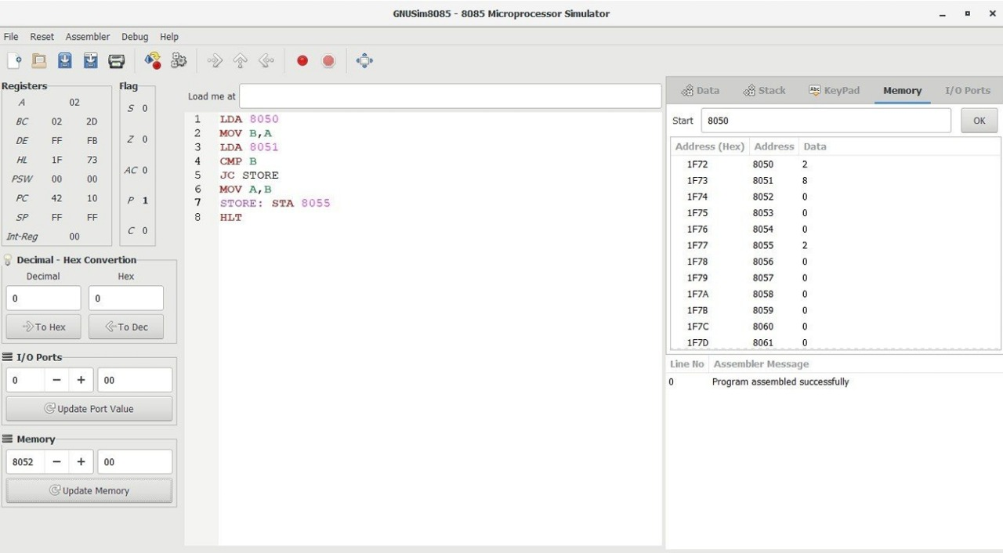

**RESULT:** Thus the program was executed successfully using 8085 processor simulator.